Awareness programmed on Anti Ragging 0N 24.01.2023

MUGBERIA GANGADHAR MAHAVIDYALAYA
[NAAC: B+ (3rd Cycle); College with Potential for Excellence (UGC);
Star College, DBT (GoI)]
(Affiliated to Vidyasagar University)
Vil+PO-Bhupatinagar, Dist.-Purba Medinipur
West Bengal, Pin-721425, Phone: 03220-270236
E-mail: mugberia_college@rediffmail.com
Date: 17.01.2023

NOTICE

It is hereby notified that an “Awareness programme on Anti Ragging” is schedule to be held on 24.01.2023 at 11.00 AM at Nutrition Department of Mugberia Gangadhar Mahavidyalaya. All 1st year students of Nutrition Department are informed to be present in this said programme.

Head
Dept. of Nutrition
Mugberia Gangadhar Mahavidyalaya

Principal
Mugberia Gangadhar Mahavidyalaya

REPORT:

Department of Nutrition organized a One day awareness programme on ''Anti Ragging” on 24th january , 2024 at 11 am-2pm onwards to help, motivate and encourage for student. Dr. Apurba Giri H.O.D. Dept of Nutrition was the main speaker of this program. Mr. Tanmoy Kumar Giri, Mrs. Sucheta Sahoo, Sruti Mandal teacher Dept. of Nutrition was valuable lecture provided in this programme. Total 38 students (Female: 26, Male: 12) with 6 faculty members (Male: 04 and Female: 02) participated in this program. Any act of physical or mental abuse targeted at another student (fresher or otherwise) on the ground of color, race, religion, caste, ethnicity, gender (including transgender), sexual orientation, appearance, nationality, regional origins, linguistic identity, place of birth, place of residence or economic background. The awareness programmed was very much successful.

PHOTOS:

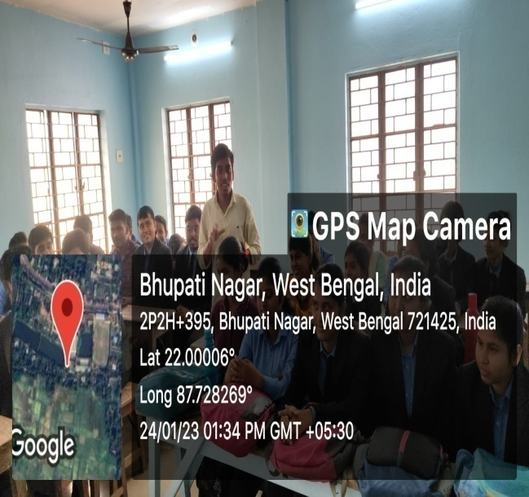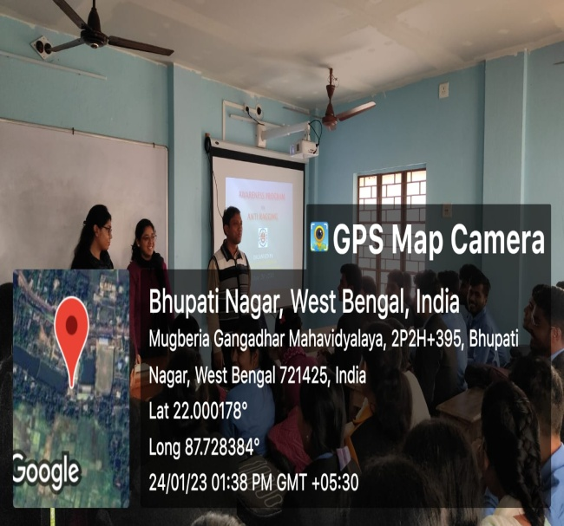
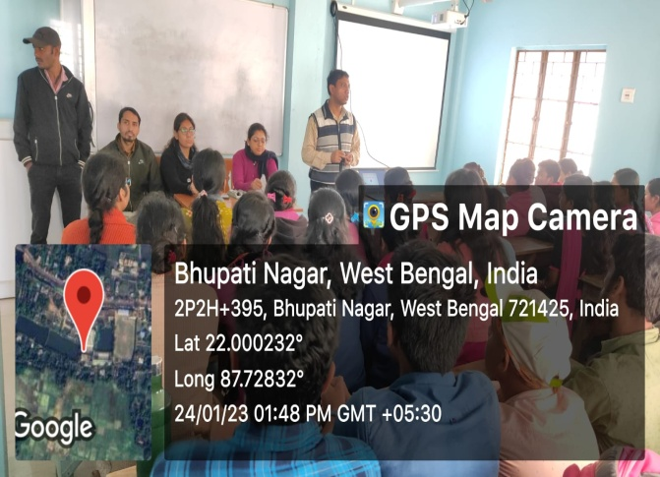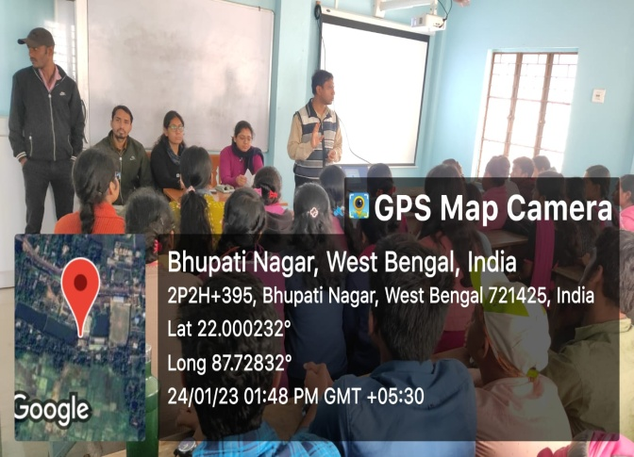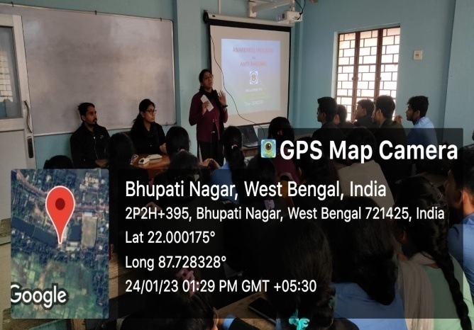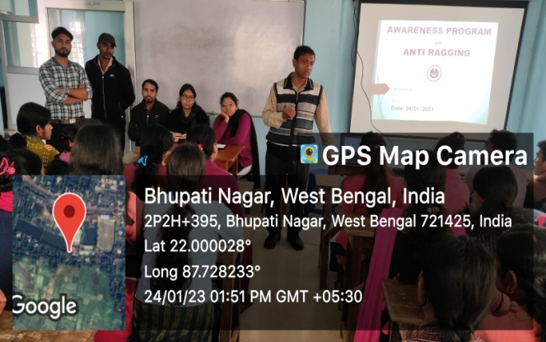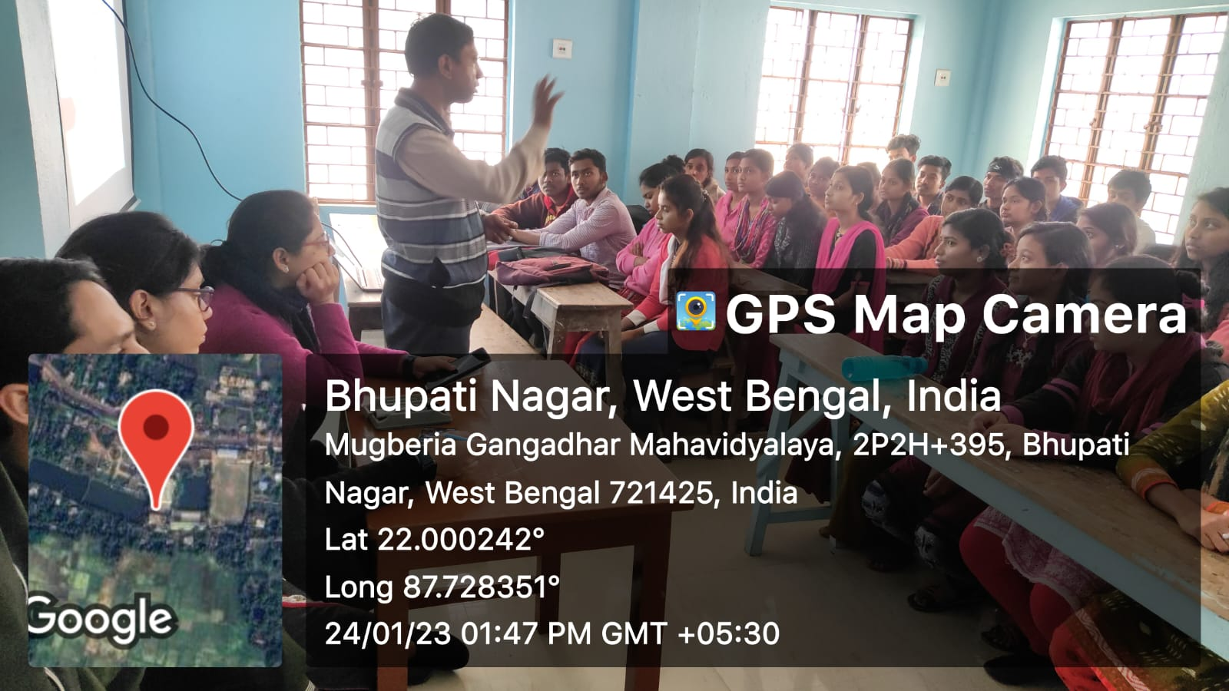

Attandance of participate:
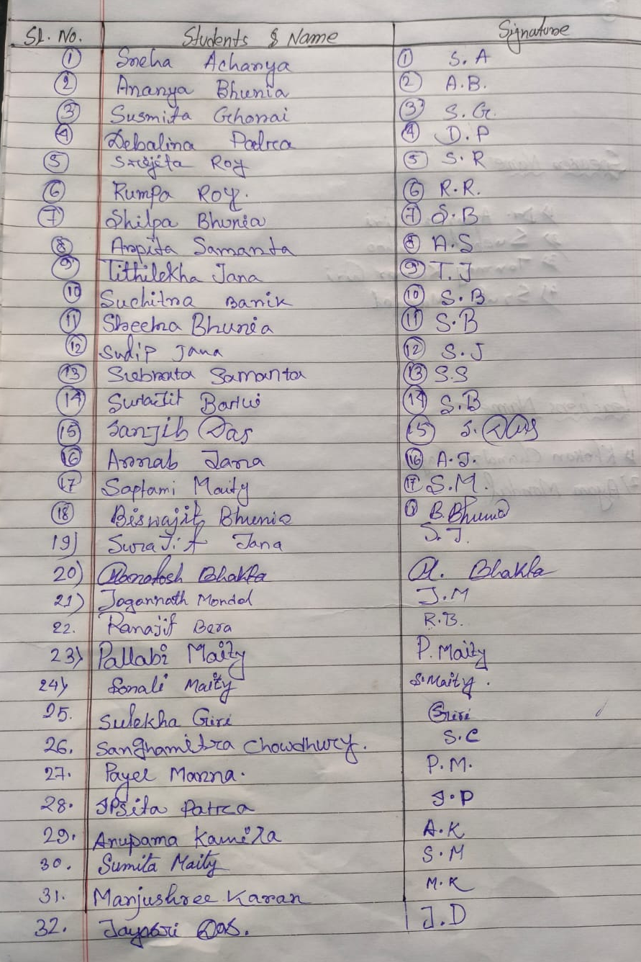

RESOLUTION:
- To aware the students of dehumanizing effect of ragging inherent in its perversity.
- To keep a continuous watch and vigil over ragging so as to prevent its occurrence and recurrence.
- To promptly and stringently deal with the incidents of ragging brought to our notice.
- To create awareness among the students about Anti ragging.
- To take all necessary measures for prevention of Ragging inside the Campus/ Hostels.

